Chapter 6
- What is the Link structure Diagram of World wide Web? How to represent this kind of Link structure Diagram?
The link structure diagram of world wide web.
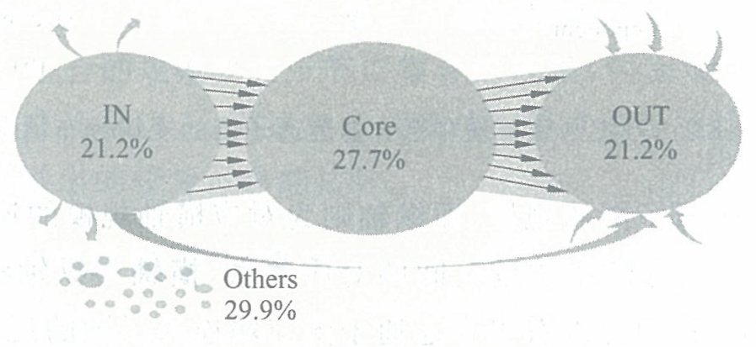
From any page in IN, you can link to any page in Core, and then you can access any page in OUT.
In addition to IN,Core,OUT, some of the pages are linked to IN,OUT and the other is not connected to IN,Core,OUT, which is about 8.2% of the total number of pages analyzed.
The link structure of the World wide Web takes Core as the core and forms the structure of the bow tie.

- Please describe the Distribution of Indegree and outdegree of WWW.

- What is the HITS ? Please give the Mathematics representation of HITS.
- Please understand the computing process of HITS. For example, a graph is the following.
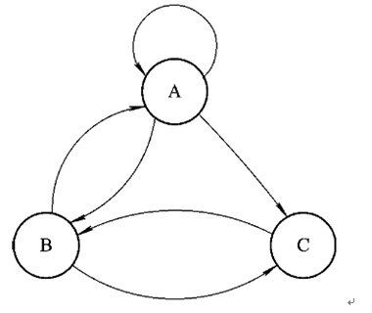
Can you write the first iteration and the second iteration?

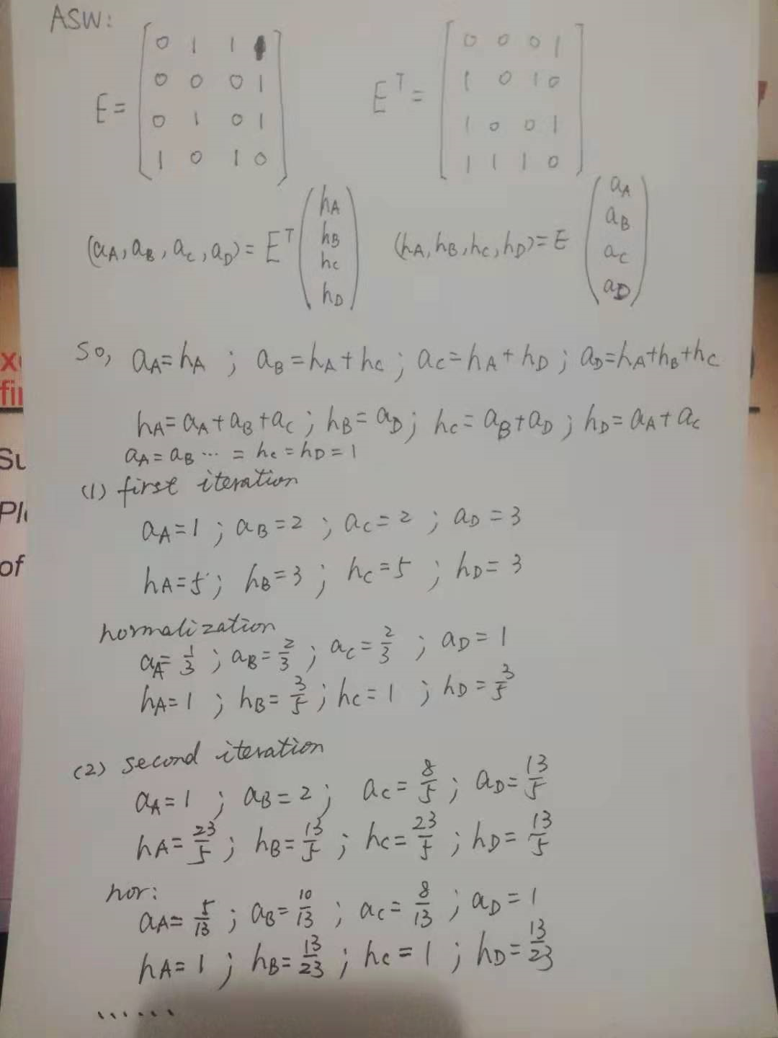

- What is the Pagerank? Can you give the computing process of Pagerank?
Pagerank is the probability that a user will visit a page when browsing the internet randomly.
Computing process of pagerank the process has three stages:
- computing the page-rank value of each paper in the system (each node in the citation network).
- assigning weighted proportions of such values to each author in the system (each node in the collaboration network).
- computing the author pagerank-index as a percentile.
- Please give some possible sorting factor for Search Engine.
For example, content similarity, the quality of web page, user preference and so on.
- Secure and Accessible
- Page Speed
- Mobile Friendliness
- Domain Age, URL, and Authority
- Optimized Content
- Technical SEO
- RankBrain
- Links
- Social Signals

